

**Assignment no 1:**

**Subject:**

Applications of ICT (CSC101)

**Submitted by:**

Muhammad Athar Abbas

SP25-BSE-082

Section – A

**Submitted to:**

Madam Maham Saleem

**Date of Submission:**

08 – March - 2025

Table of Contents:

Problem Statement – **Page 3**

Introduction – **Page 3**

Early Computers – **Page 4**

First Generation Computers – **Page 5**

Second Generation Computers – **Page 5**

Second Generation Computers – **Page 6**

Third Generation Computers – **Page 6**

Third Generation Computers – **Page 7**

Fourth Generation Computers – **Page 7**

Fifth Generation Computers – **Page 7**

Summary Table – **Page 8**

**Problem Statement:**

Discuss different generations of the computers in details. Your discussion should contain the basic technology used, benefits, drawbacks, their users, programming languages used, what type of input, output and storage devices used.

**Introduction:**

A computer is a programmable, electronic device that accepts data, performs operations on that data, presents the results, and stores the data or results as needed.

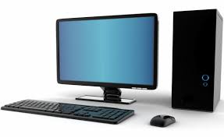

The history of Computing and Computers goes back to ancient times. Archeaological evidences tells us that people in old era had the ability to do calculations and perform certain mathematical operations. Then people started to use devices to aid them in their calculations. Abacus was a hand operated calculating tool which was used in ancient Near East and China. Tabulating Machine and Mechanical calculators were invented. ENIAC / UNIVAC were developed in 1940’s, 50’s. They were used as military tools. After that transistors were introduced in computers, making them more energy efficient , later computers used Integrated Chips (IC’s) , and now in present era Microprocessors are the essential part of computers.

Here we see , a detailed history of Computers , how it started from Abacus using beads for basic counting to present era computer harnessing the power of microprocessors to perform billions of calculations in mere seconds.

**Early Computers (**before 1946**):**

One of the earliest known calculation device is ancient Near East’s *Abacus* , used for counting and basic mathematical operations like addition, subtraction and multiplication . It used beads. Several less known devices were made in later era.

Mechanical Calculators were invented in 19th century. Punch Card computing was very common in that era. Punch cards were card stock with punched holes used for data processing. Tabulating Machine is an example of calculating device based on punch cards. Later , 20th century marked the beginning of First Generation of Computers.

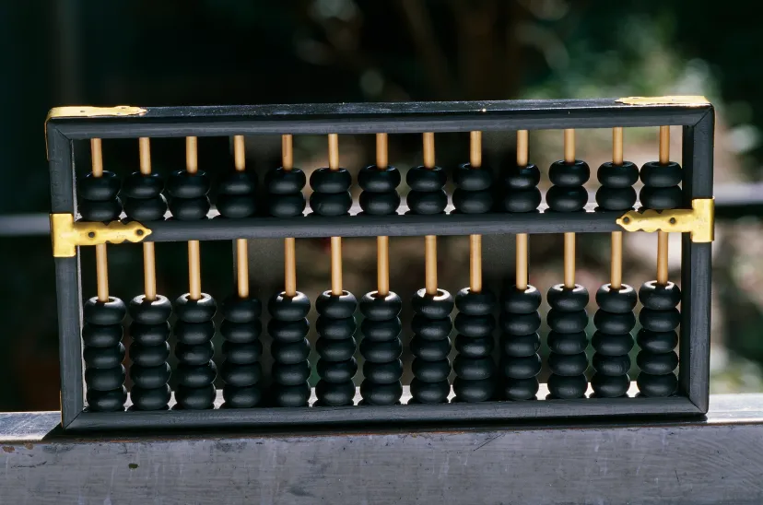

**First Generation Computers (**1946 – 57**):**

First Generation Computers were enormous. They often took entire rooms. Vacuum tubes were used for powering them. Two of the great examples of First Generation computers are ​​*UNIVAC* and *ENIAC.*

ENIAC was developed in WW1 , completed in 1946. It had military uses e.g to form artliary firing tables. UNIVAC was developed by US Census Bureau in 1951 to analyze votes. The calculations which took years to solve, were performed in minutes by these computers. But first general purpose computers had major drawbacks.

* They were enormously large hence difficult to house.
* They were not energy efficient . A very large amount of electricity was needed to power them.
* They generated lot of heat.
* They needed physical rewiring for programming thus difficult to maintain.

**Second Generation Computers (**1958 – 63**):**

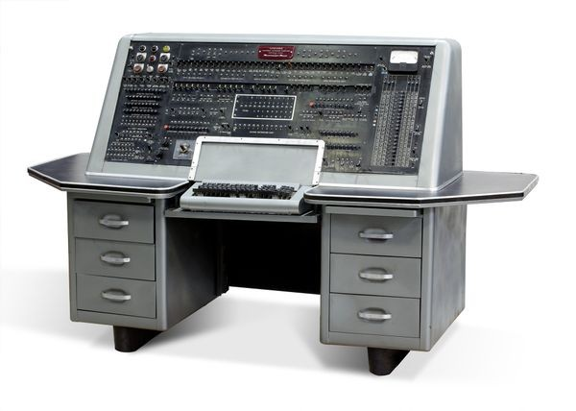 UNIVAC (Universal Automatic Computer)

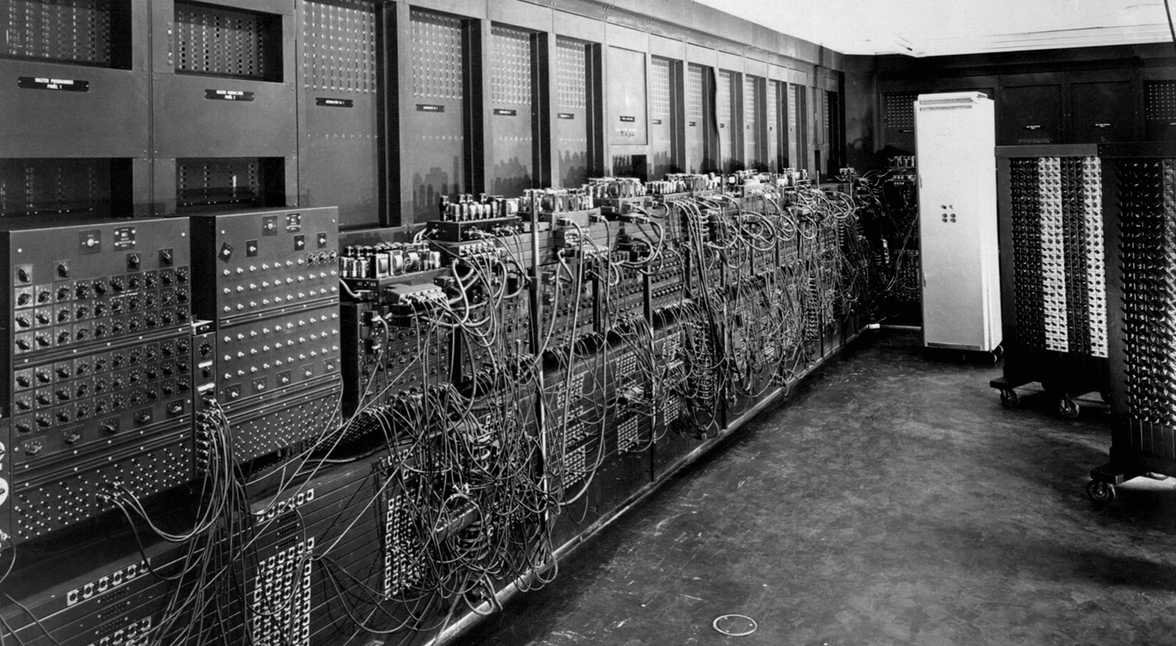ENIAC (Electronic Numerical Integrator And Computer)

This era marked the beginning of use of *transistors* in computers. Transistors are made of semiconductor material and they act as a switch in circuits. They were much smaller than vacuum tubes, this made computers more energy efficient and cost effective than First Generation of computers. They were also more powerful.

For input punch cards and magnetic tapes were used , while output was taken on paper printouts. This generation computers utilized Hard Drives for storage , and languages like FORTRAN and COBOL were also developed in this generation.

Example of this generation of computer is IBM’s mainframe IBM 1401.

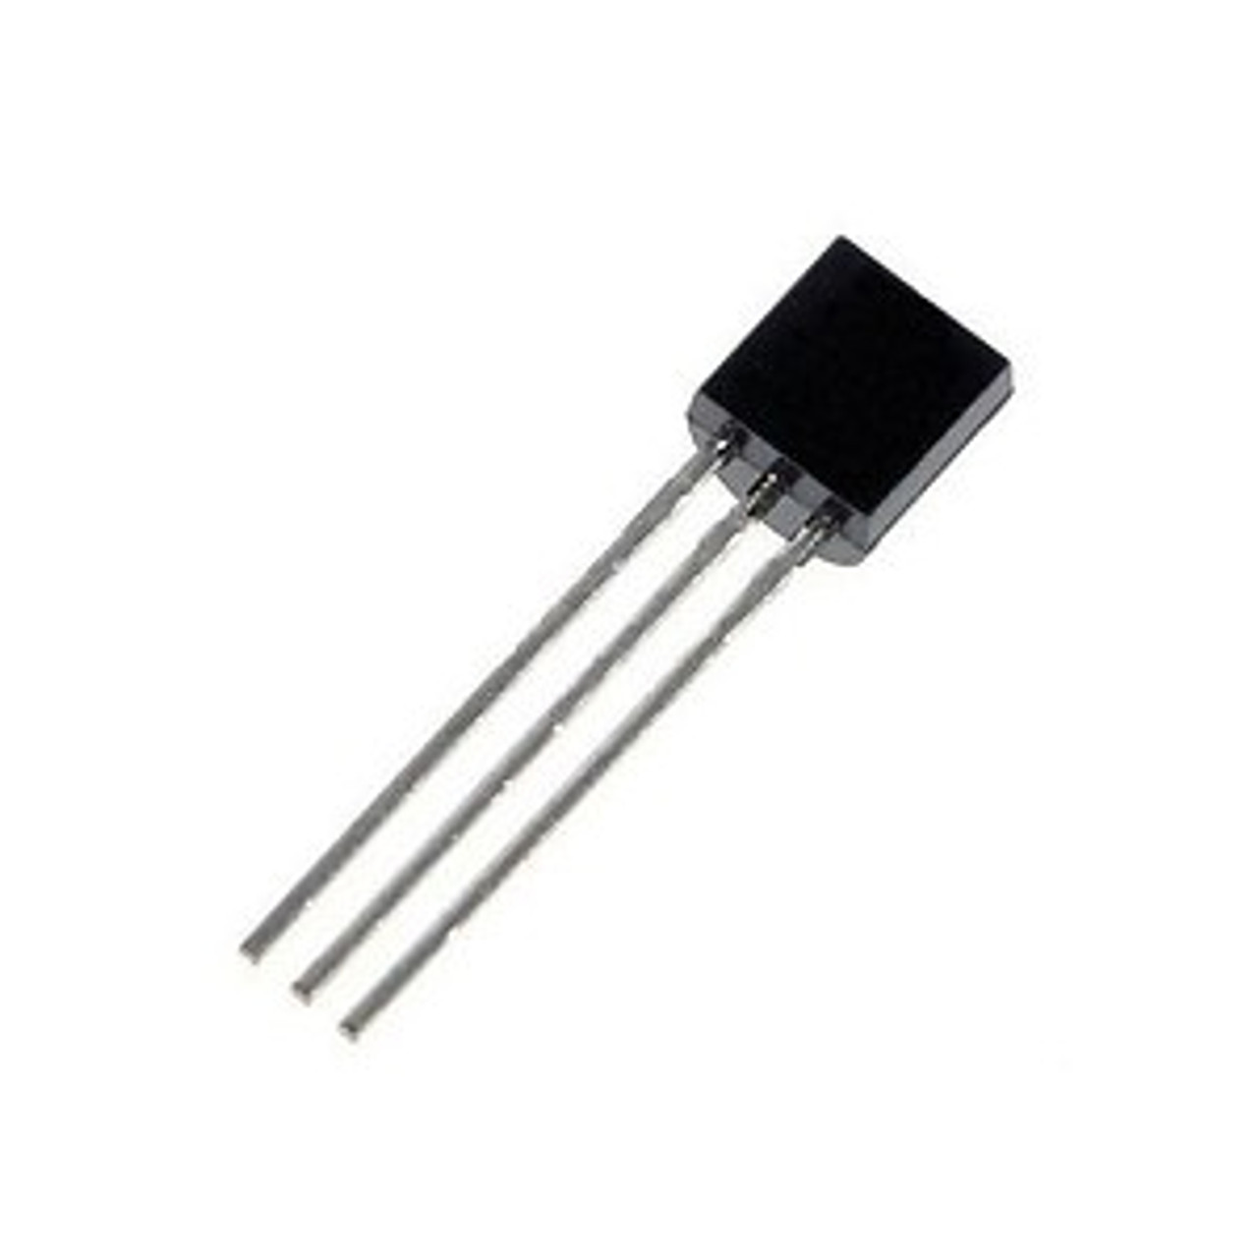 A Silicon Transistor

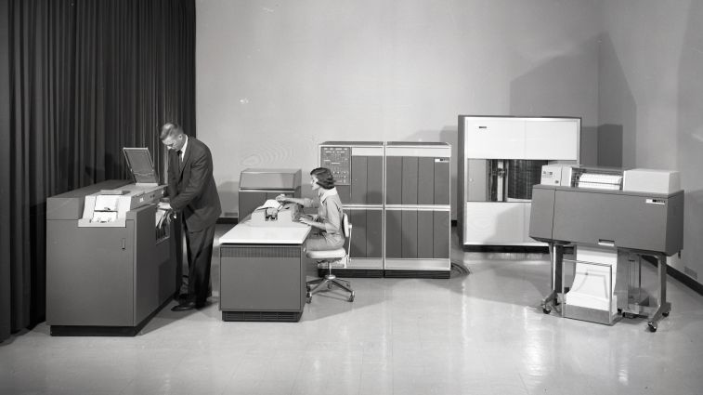Mainframe IBM 1401

**Third Generation Computers (**1964 – 70**):**

Integrated Circuits *– which put billions of transistor in a single chip –* were the major innovation in this era. These computers were smaller and more reliable , though IC’s were a little complex to develop and difficult to maintain.

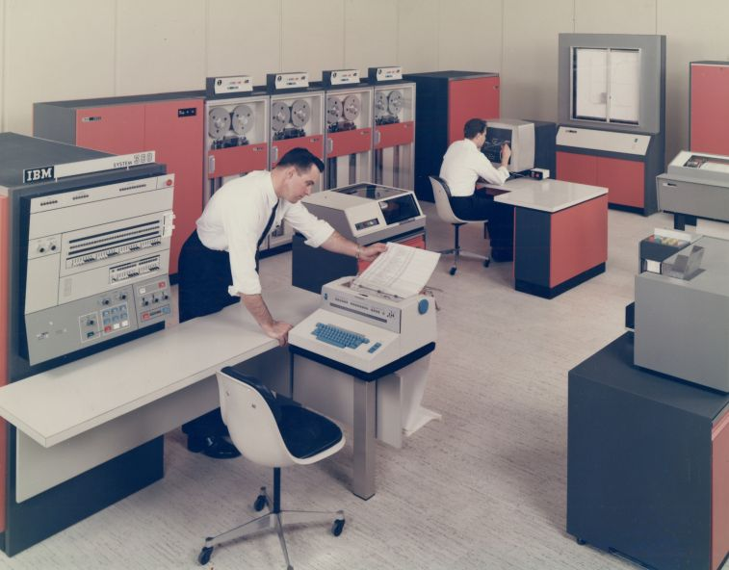 IBM System 360

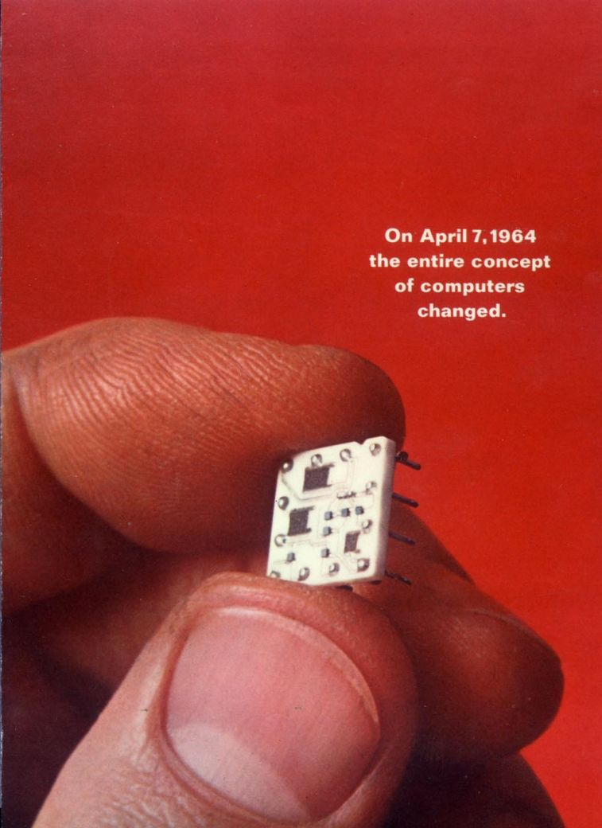

They used keyboards for input and monitors for output and used hard drives for storage. The well known programming language like C was developed in this era , other common languages were Basic and Pascal etc. An example of this era computer is IBM System 360.

**Fourth Generation Computers (**1971 – present**):**

The development of Integrated circuits led to even more complex circuits namely *Microprocessors ,*  whose task it to read specific instructions, process them and generate relative output , often called as the Brain of computer. Intel was the first company to develop microsprocessors. These computers required less electricity and were less expensive hence making them available to general public use.

These computers commonly use keyboard and mice for input and Monitors and printers for output. Hard drives , flash memory and optical disks are common storage devices. Computer networks and wireless technologies are largely used in this era. Apple Macintosh and IBM PC are early computers of this generation.

**Fifth Generation Computers (** present and future**):**

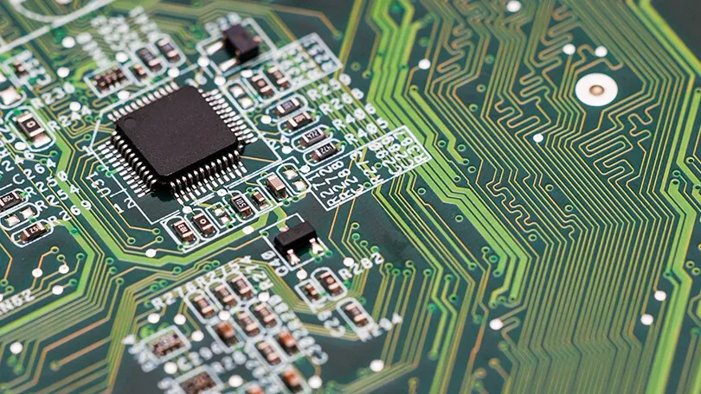A CPU (Central Processing Unit)

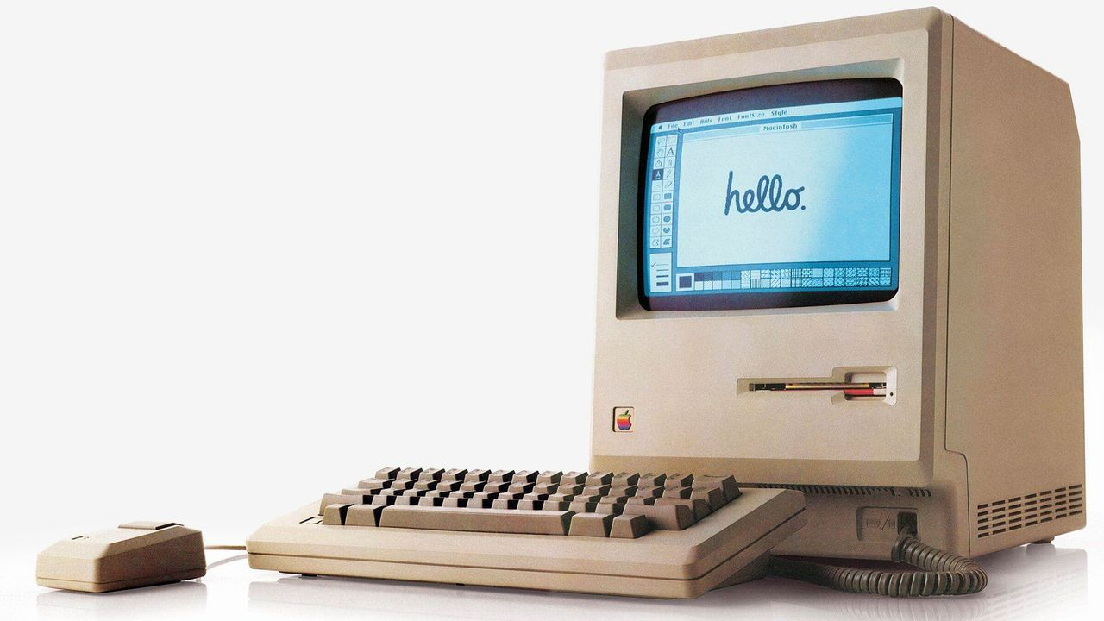Apple's Macintosh

Fifth generation computers are to be based on *Artificial Intellgence ,* means they can use AI to think , reason and learn. This can be achieved by making computers capable of processing natural languages. This decade is seeing a boom in AI , as multiple companies have released their Generative AI models, and lots of research is going in the field of machine learning.

Future computers could perfom optical processing , I.e to use light instead of electric current and use nanotechnology to make components at very atomic level or general purpose computer could be installed in everday devices.

**Summary:**

Later half of 20th century saw an exponential growth in technology of computers , and its still going on. Here is a table presenting the summary of all computer generations.

| Generation | Time Period | Technology Used | Examples | Programming Languages |
| --- | --- | --- | --- | --- |
| First | 1946–1957 | Vacuum Tubes | ENIAC, UNIVAC | Machine Language |
| Second | 1958–1963 | Transistors | IBM 1401 | FORTRAN, COBOL |
| Third | 1964–1970 | Integrated Circuits (ICs) | IBM System 360 | C, BASIC, Pascal |
| Fourth | 1971–Present | Microprocessors | Apple Macintosh, IBM PC | C++, Java, Python |
| Fifth | Present & Future | AI, Quantum Computing, Nanotechnology | AI-driven systems, Quantum Computers | Python, Lisp, Prolog |